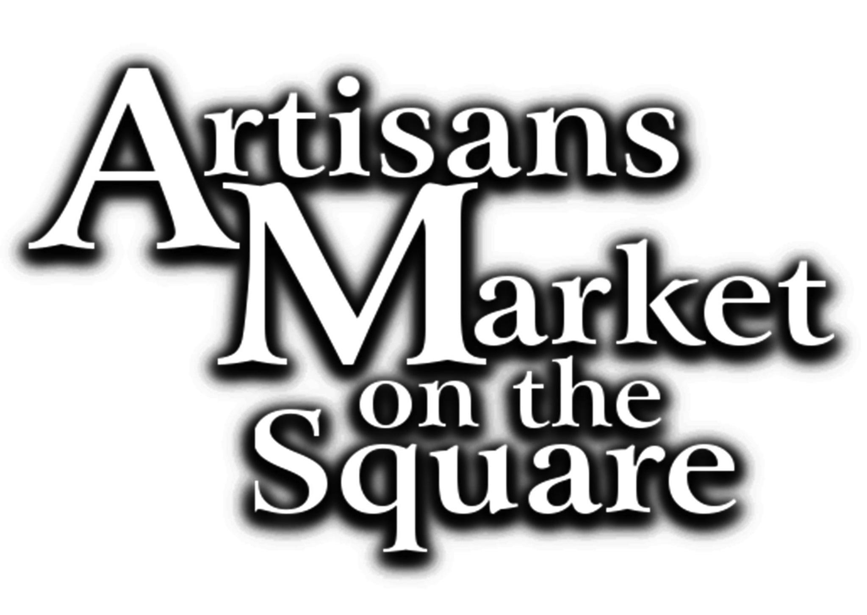
ARTISANS MARKET ON THE SQUARE
www.artisansmarketonthesquare.com
Application Form

Hours: Friday 11 to 6; Saturday 9 to 4
I am applying for:

____ Folk Festival April 16 – 17, 2021 Mountain View, Arkansas, (3rd Friday and Saturday in April) Deadline for entry April 1.

____ Bean Fest Oct 22 – 23, 2021 Mountain View Arkansas, (Last Friday and Saturday in October) Deadline for entry Oct. 1.

Name: _________________________________________________________________

Business Name: _________________________________________________________

Address: _______________________________________________________________

City __________________________________________ State ______ Zip _________

Day Phone _____________ Evening Phone ____________ Cell Phone: _____________

E-mail__________________________________________________________REQUIRED

Calculate Fees:
_____ I will be the only artist in my booth (10’x10’ with one artisan $75)
_____ I will be sharing the booth with the artisans listed below. (There is an additional charge of $25 per artisan)
Please list names of additional artisans: ________________________________
(each artisan must submit their own application)
$ _______ One Artist Fee ($75)
$ _______ Additional Artist Fee ($25 for each)
$ _______ Additional 10’x10’ Space ($50)

$ _______ TOTAL FEES DUE

Arkansas Sales Tax Number _________________________________________________

Medium/Category of items to be sold: ________________________________________

Briefly describe the products to be sold:_______________________________________
___________________________________________________________________________________________________________________________________________________________________________________________________________________________(Only items described on this form will be permitted at the Market)

____ Previous Artisans Market or Christmas Showcase vendor
____ I am a new applicant. I have emailed four images of my work and one of my booth to arkansascraftguild@gmail.com Questions? 870-269-4120.
(Be sure to put ARTISANS MARKET JURY in the subject line)

Artist Agreement
___I will only be selling work that I handcrafted.
___I agree to abide by the Guidelines of the Artisan’s Market.
___I understand that neither the City of Mountain View, nor the Artisans
Market on the Square, nor the Arkansas Craft Guild is responsible for any loss, damage, or stolen merchandise or personal injuries, nor will I be a party to any legal action.
___I agree to be ready to begin selling my products at 11:00 AM on Friday, and I will not leave the show until 4:00 PM on Saturday of the Artisans Market.
___I authorize the Arkansas Craft Guild to use my photos and biographical material for publicity purposes in advertising and show publications.
Even if you aren’t required to jury, new photos of your work will greatly aid our Facebook or Instagram publicity efforts. @artisansmarketonthesquare.

ONLY ARTISANS WHO AGREE FULLY TO THIS CONTRACT WILL BE ACCEPTED:
Signature ______________________________________________ Date ___________ Mail this completed application with check for the amount calculated above made out to “Arkansas Craft Guild” to: Arkansas Craft Guild, P.O. Box 800, Mountain View, AR 72560 or we can bill you on Square for credit card purchase by email arkansascraftguild@gmail.com.

