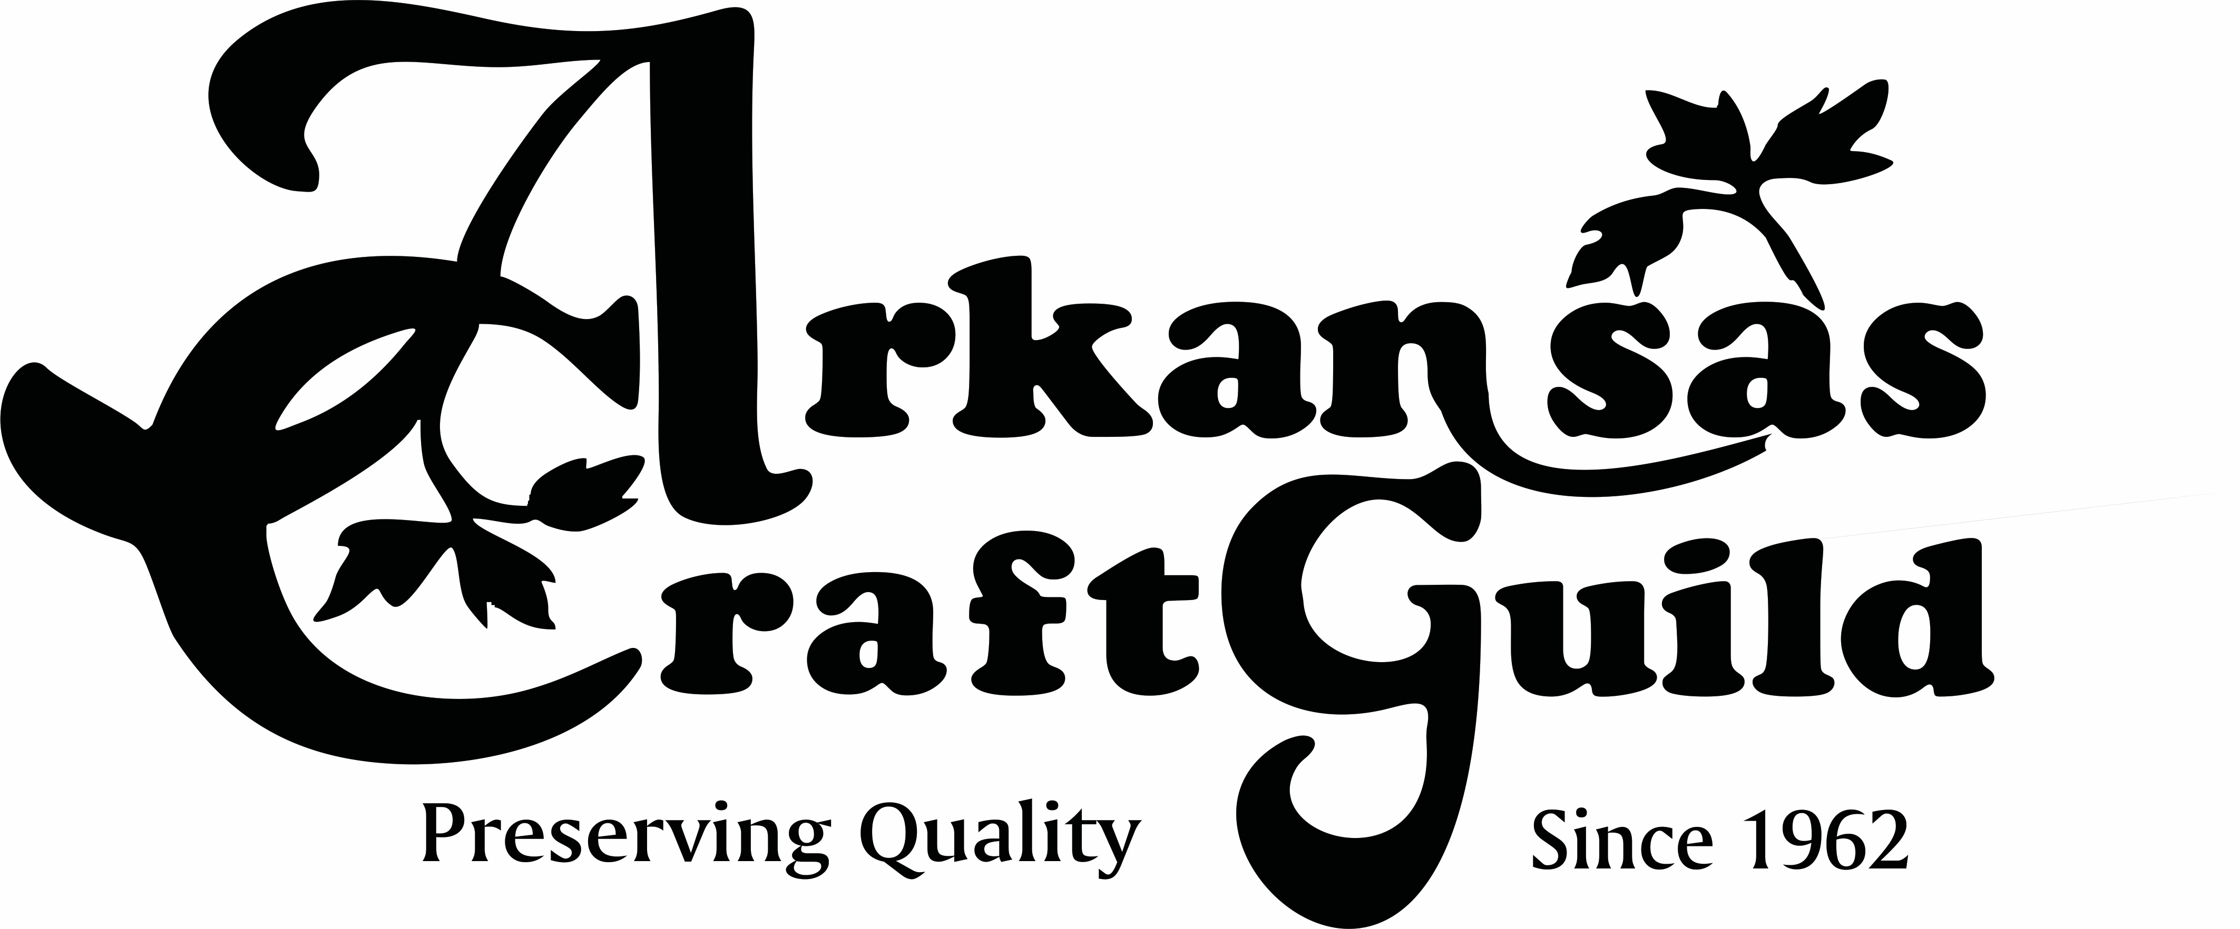
Arkansas Craft Guild 43rd Annual Christmas Showcase
December 3, 4, & 5, 2021

Arkansas State Fairgrounds Hall of Industry
2600 Howard St., Little Rock, AR

Non Member APPLICATION to jury

DEADLINE FOR APPLYING: October 15 (strictly enforced)

This is a juried show. All work must be original - designed and crafted by the artist who must be present at the show. Arkansas Craft Guild Members and returning Christmas Showcase guest artists do not need to jury for this show. If you have done the show in the past, please fill out a Reservation form, available by request, online form at Facebook @christmasshowcase or on our website www.arkansascraftguild.org.

The Arkansas Craft Guild is committed to ensuring the continued quality of items sold at this show. Work displayed and sold at this show must be representative of the work the artist submitted for jury. Jury committee members will be checking booths to ensure the quality and type of the work matches what was submitted. Artists may be asked to remove work from their booth that does not meet these requirements.

NEW APPLICANTS: Must submit 5 images of your work and one of your booth display and a completed application by email to arkansascraftguild@gmail.com with CHRISTMAS SHOWCASE JURY in the subject line. Pictures should still be submitted by email. If you are unable to email your information, you may send a CD or thumb drive with images of your work and your completed application to Arkansas Craft Guild Christmas Showcase, P. O. Box 800, Mtn. View, Arkansas 72560. The images will be sent to the Christmas Showcase jury committee. You will be notified by email of the jury’s decision. Questions, call Arkansas Craft Guild office 870-269-4120 or email arkansascraftguild@gmail.com.

A $15.00 nonrefundable jury fee will be charged, along with booth fees, if you are accepted. We must receive at least a $100 deposit on your booth before one is reserved.

Guest artists need not be an Arkansas resident. Complete this application and return with 6 images.

Artist Name(s): _____________________________________________________________________________

Business Name: ____________________________________________________________________________

Mailing Address: ____________________________________________________________________________

City: ________________________________________________State: ________ Zip Code: _____________

Telephone Numbers: ________________________________________________________________________

Email Address: _____________________________________________________________________________

Website: _________________________________________________________________________________

Media Category(s):__________________________________________________________________________

PAYMENTS

______$15 jury fee

2021 BOOTH FEES NOTE: all booth fees include electricity: (BOOTH FEES ARE SUBJECT TO CHANGE. PARTICIPANTS WILL BE NOTIFIED IMMEDIATELY OF ANY CHANGES IN FEES.)

Please indicate the booth size you are requesting.

_____ 10 x 10 @ $325
_____ DOUBLE BOOTH along wall $550
_____ DOUBLE BOOTH in center w/ corner $575 (limited availability)
_____ 10 x 10 corner in center $350 (limited availability)
_____ 10 x 15 along wall $450
_____ 10 x 15 in center w/ corner $475 (2 artists must request this to share a 3 booth segment.)

# ______Tables @ $12 ea $________total
# ______Chairs @ $3 ea $________total

$_________TOTAL COST

$_________ Booth reservation fee ($100.00 Minimum upon acceptance - Reserved only after payment)

$_________ Balance Due (By November 1, 2021 - $25.00 late fee after that date)

Cancellation Policy: Cancellations before October 15 will be charged a $25 handling fee, deducted from the refund. No refunds after 10/15/2021.

Please send applicable check(s) payable to
ARKANSAS CRAFT GUILD
PO BOX 800
MOUNTAIN VIEW, AR 72560, or ask to be billed through Square to your email.

Payment Method:

Check #_________ Amount $______________ Dated ________________ Received by__________________

Credit card: Number _______________________________ (or, request billing below by credit card on Square)

Name on Card ________________________________Exp. Date__________CVV on back of card __________

Signature ___________________________________________________ Date _________________________

____Bill me via Square using my email (if different than above) _____________________________________

____Pay via PayPal to our email arkansascraftguild@gmail.com

