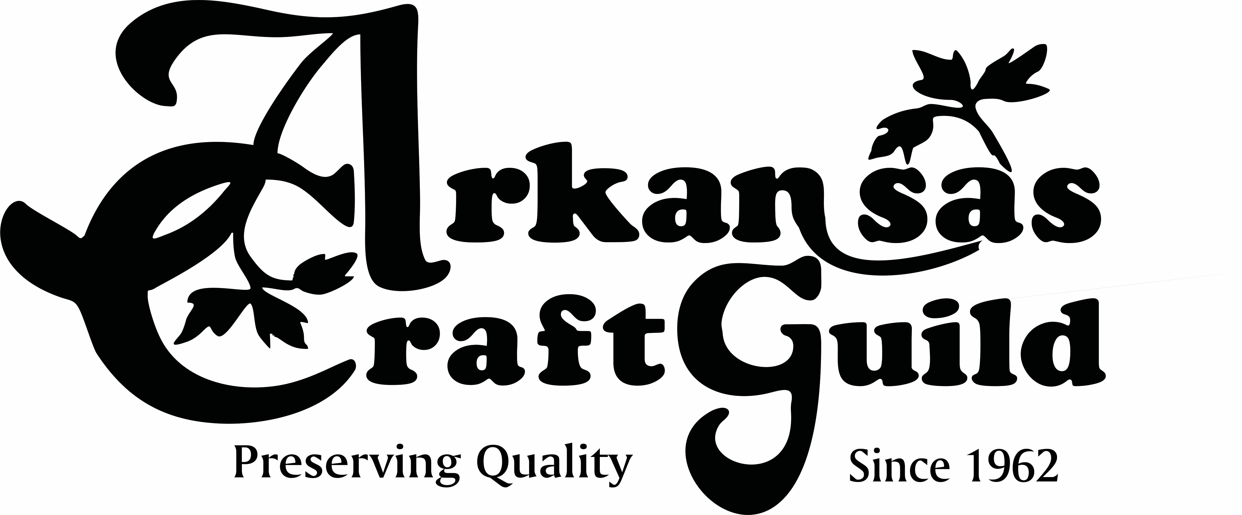
Arkansas Craft Guild Christmas Showcase December 3, 5 & 5, 2021
Arkansas State Fairgrounds Hall of Industry
2600 Howard St., Little Rock, AR

Returning Artist’s Booth Reservation Form
NO JURY REQUIRED for Guild Member or Past Participants

DEADLINE TO APPLY: October 15, 2021 (STRICTLY ENFORCED)

Artist Name(s): _____________________________________________________________________________________

Business Name (as displayed on booth sign): _____________________________________________________________

Media Categories:___________________________________________________________________________________

Guild Member: ___ YES ____ Member # (2021 dues must be paid to get Member booth rate)
___ NO ____ Applying at Christmas Showcase (by Nov. 20, completed member application)

Mailing Address: ____________________________________________________________________________________

City: ______________________________________________________State: ________ Zip Code: _________________

Telephone Number: _____________________________________Cell Phone: ___________________________________

Email Address: ______________________________________________________________________________________

Website: __________________________________________________________________________________________

2021 BOOTH FEES - Note: all booth fees include electricity:

ACG Member Non Member
__ 10 x 10 @ $275 __ 10 x 10 @ $325
__ DOUBLE BOOTH along wall $500 __ DOUBLE BOOTH along wall $550
__ DOUBLE BOOTH IN CENTER – w/corner $525 __ DOUBLE BOOTH IN CENTER w/corner $575
__ 10 x 10 corner in center $300 __ 10 x 10 corner in center $350
__ 10 X 15 along wall $400 __ 10 x 15 along wall $450
__ 10 X 15 in center w/corner * $425 __ 10 x 15 in center with corner* $475
#____Tables @ $12 ea $________ #____Tables @ $12 ea $________
#____Chairs @ $3 ea $________ #____Chairs @ $3 ea $________
*Note: 2 artists must request this to share a 3 booth segment.
$__________ Total cost
$__________ Booth reservation fee ($100.00 minimum)
$__________ Balance Due (by November 1, 2021 - $25.00 late fee after that date)

Cancellation Policy: Cancellations before November 1 will be charged a $25 handling fee, deducted from the refund. No refunds after November 1, 2021.
Questions? Guild office 870-269-4120 or arkansascraftguild@gmail.com

The Arkansas Craft Guild is committed to ensuring the continued quality of items sold at this show. Work displayed and sold at this show must be representative of the work the artist submitted for jury. Jury committee members will be checking booths to ensure the quality and type of the work matches what was submitted. Artists may be asked to remove work from their booth that does not meet these requirements.

Return this application and your check (payable to Arkansas Craft Guild) to
ARKANSAS CRAFT GUILD
PO BOX 800
MOUNTAIN VIEW, AR 72560, or email application to arkansascraftguild@ gmail.

____Please bill me through Square using my email ___________________________________________(if different)

____Pay using PayPal – use our email arkansascraftguild@gmail.com.

Payment Method:

Check #_________ Amount ___________________Dated: ____________________Received by____________________

Credit card: Number ________________________________________________ (or, check X invoice above with Square)

Name on Card __________________________________Exp.Date_______________CVV code on back of card ________

Signature ________________________________________________________________ Date _____________________

